**Product Service**

Data Model

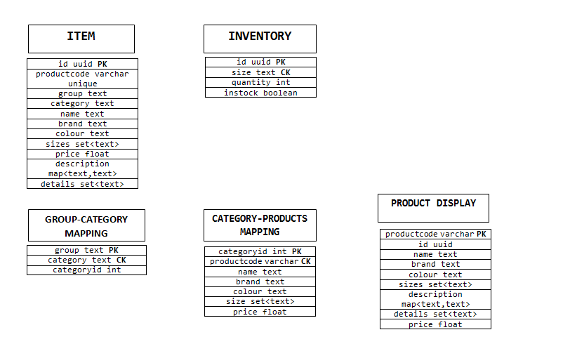

//ITEM table is used to store all the details of the products.

//INVENTORY table is to store the quantity of each product.

//TAGS table stores the tags of a product which can be used to search a product.

//GROUP-CATEGORY MAPPING table can be used to get all groups and map to all categories of a group.

//CATEGORY-PRODUCTS MAPPING table can be used to map products to a particular category.

//PRODUCT-DISPLAY table can be used to display a product detail.

----------------------------------------------------------------------

CREATE KEYSPACE product_service WITH replication = {'class': 'SimpleStrategy', 'replication_factor': '3'};

...........................................................

CREATE table item (

id uuid,

productcode varchar,

name text,

group TEXT,

category TEXT,

brand text,

color text,

size set<TEXT>,

price float,

imageUrl text,

description map<text,text>,

Details set<text>,

PRIMARY KEY (id)

);

create table inventory (

id uuid,

size text,

quantity int,

instock boolean,

primary key((id),size)

);

create table group_category_mapping (

group text,

category text,

categoryid int,

primary key((group),category)

);

create table category_products_mapping (

categoryid int,

productcode varchar,

name text,

brand text,

color text,

Size set<text>

description map<text,text>,

price float,

primary key((categoryid),productcode));

create table product_display (

productcode varchar,

id uuid,

name text,

brand text,

price float,

size set<text>,

description map<text,text>,

details set<text>,

primary key(productcode)

);

----------------------------------------------------------------------

//to view all group names

select distinct group from group_category_mapping;

//select distinct categories mapped to a group

select category from groups_category_mapping where group=?;

//select products of particular group and category

select * from category_products_mapping where categoryid=?;

//select a product for display

select * from product_display where productcode=?;

......................................................................

Filtering products in category_products mapping

//filter by colour

CREATE INDEX item_color_idx ON category_products_mapping(color);

Select * from category_products_mapping where color=?;

//filter by brand

CREATE INDEX item_brand_idx ON category_products_mapping(brand);

Select * from category_products_mapping where color=?;

//filter by size

CREATE INDEX item_size_idx ON category_products_mapping(size);

select * from category_products_mapping where size contains 's' allow filtering;